Chapter 13, Problem 4.

(a) For the coupled coils in Fig. 13.74(a), show that

L_{eq} = L₁ + L₂ + 2M

(b) For the coupled coils in Fig. 13.74(b), show that

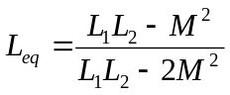

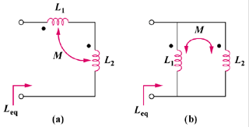

Figure 13.74
For Pro. 13.4.

